Darshan J Patel
21BCE6061

Os lab – 5

1.

Code - 1.Write a C program to generate a child process using 4 system call. You can generate any number of child process as required. Get the number of child process to be generated as a input from the user and those child process should be generated for the same parent process. Display the child process and the parent process ID(use getpid() for child process ID and getppid() for parent process ID).

#include <stdio.h>
#include <unistd.h>
#include <stdlib.h>
#include <sys/wait.h>

void child_process(int id, int sleep_time) {
printf("Child process %d with ID %d created (Parent ID %d)\n", id, getpid(), getppid());
sleep(sleep_time);
printf("Child process %d with ID %d terminated\n", id, getpid());
exit(0);
}

int main() {
pid_t pid[4];
int sleep_times[4] = {3, 2, 5, 4};

// Creating 4 child processes
for (int i = 0; i < 4; i++) {
pid[i] = fork();
if (pid[i] == -1) {
perror("fork");
exit(1);
} else if (pid[i] == 0) {
child_process(i+1, sleep_times[i]);
}
}

// Waiting for child processes to terminate
int status;
waitpid(pid[2], &status, 0);
waitpid(pid[1], &status, 0);
waitpid(pid[3], &status, 0);
waitpid(pid[0], &status, 0);

// Terminate the parent process after all child processes have terminated
printf("Parent process with ID %d terminating\n", getpid());
exit(0);
}
ss
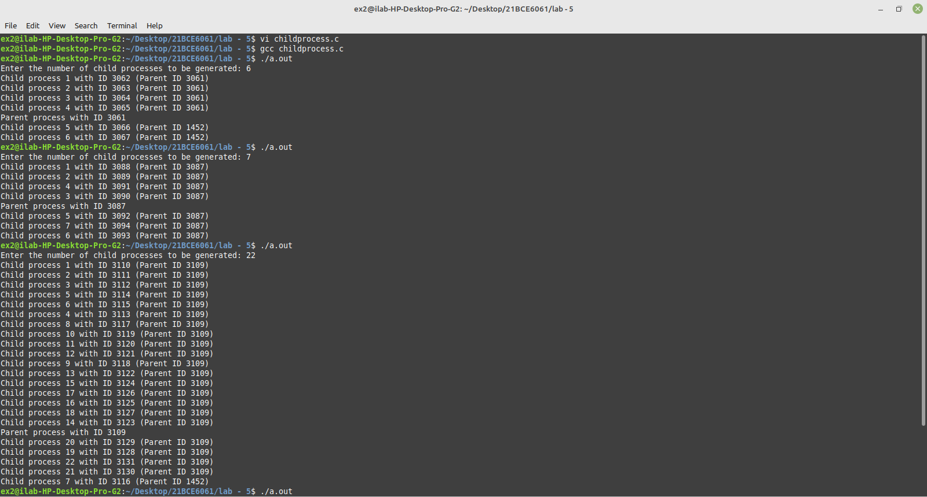
2.
(a)
#include <stdio.h>
#include <stdlib.h>
#include <unistd.h>
#include <sys/wait.h>

int main() {
pid_t pid[4];
int i, status;

// create 4 child processes
for (i = 0; i < 4; i++) {
pid[i] = fork();
if (pid[i] == -1) {
printf("Error creating process\n");
exit(1);
} else if (pid[i] == 0) {
printf("Child process %d with id %d\n", i+1, getpid());
exit(0);
}
}

// wait for all child processes to terminate
for (i = 0; i < 4; i++) {
waitpid(pid[i], &status, 0);
printf("Child process %d with id %d terminated\n", i+1, pid[i]);
}

// parent process terminates last
printf("Parent process with id %d terminating last\n", getpid());

return 0;
}

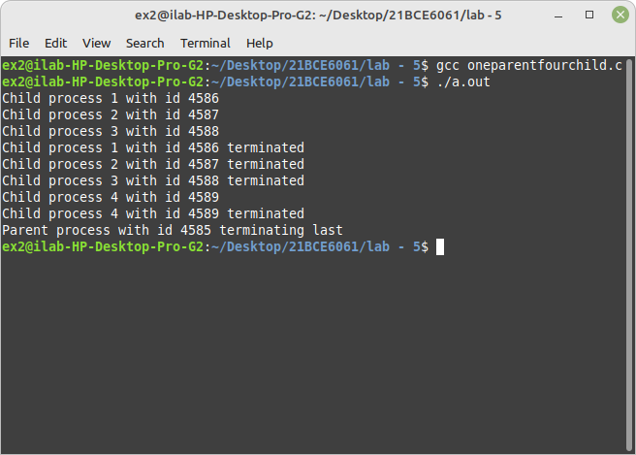
2.
#include <stdio.h>
#include <stdlib.h>
#include <unistd.h>
#include <sys/wait.h>

int main() {
pid_t pid, wpid;
int status = 0;
int i;

// Create four child processes
for (i = 1; i <= 4; i++) {
pid = fork();

if (pid == -1) {
perror("fork error");
exit(EXIT_FAILURE);
}
else if (pid == 0) { // Child process
printf("Child process %d with PID %d created\n", i, getpid());
sleep(5); // Sleep for 5 seconds before terminating
printf("Child process %d with PID %d terminated\n", i, getpid());
exit(i); // Terminate with exit status equal to i
}
}

// Wait for the fourth child process to terminate first
while ((wpid = wait(&status)) > 0) {
if (WIFEXITED(status)) {
if (WEXITSTATUS(status) == 4) {
printf("Fourth child process with PID %d terminated last\n", wpid);
break;
}
}
}

// Wait for the remaining child processes to terminate in any order
while ((wpid = wait(&status)) > 0) {
if (WIFEXITED(status)) {
printf("Child process with PID %d terminated\n", wpid);
}
}

// Parent process terminates last
printf("Parent process with PID %d terminated\n", getpid());

return 0;
}
